**ChildToy Project Plan**

**Executive Summary** **2**

**Development Methodology** **2**

**Accepted Requirements** **3**

**Project Milestones, Deliverables** **4**

Project Management Tool 4

Project Phases 4

**Legal Compliance** **5**

**Communication and Documentation** **6**

Status Report 6

**Quality Assurance** **7**

**Project Acceptance Criteria** **8**

**References** **8**

**Appendices** **10**

Appendix A - Demo Requirements Justification 10

The system should run on L/W/IOS 10

Data Must be Stored in the most efficient way 10

Additional languages should be available as free downloadable packs. 10

A player should be able to create a user profile 10

A player should be able to create a persona 11

Appendix B - Initial UX Design Concepts 11

B.1 Login Page 11

B.2 Registration Page 11

Appendix C - Sprint Estimation 12

Appendix D - Initial ERD Design 13

Appendix E - Report Status Definitions 13

Appendix F - Scope Change Management 14

# 

# Executive Summary

This document provides the definition of the project, addressing and capturing its characteristics and limitations, and how to deliver and evaluate the outcomes.

The purpose of this project is to develop a web-based game that satisfies the requirements proposed by the customer - ChildToy. We intend to evaluate the potential and end-user feedback so as to provide a basis for future improvements.

# Development Methodology

ChildToy will be developed and delivered in Scrum due to the following reasons:

* Scrum enables flexibility and adaptability. The development team can work simultaneously rather than sequentially. Developers do not wait until all the questions are addressed before they start to code. Changes can be evaluated and adapted into a project during the life of the project (Sharma and Hasteer, 2017; Srivastava, Bhardwaj and Saraswat, 2017).
* As planned, there are only five requirements included in the demonstration, tasks should be prioritised by the order of importance. Thus, the ultimate goal of a sprint is to complete as soon as possible usable pieces of prioritised work that will have business value. Scrum removes unnecessary factors to affect the team’s velocity, such as a boss telling them what to do. The development team as a whole is responsible for what is required and this results in faster outcomes delivery with higher quality and success (Schwaber K.,1997) .
* Using Scrum, the development team works with the product owner to determine what is included in each sprint. In this way, the team knows exactly what they need to offer. It also reduces the likelihood that your build will contain surprises or unplanned features. Quality Assurance (QA) and user acceptance testing (UAT) will occur throughout the development lifecycle to ensure acceptance criteria have been met and shippable code is being produced. A key reason for this is that the product owner can quickly try out usable segments of the product and constantly give feedback on their findings. This process contributes greatly to customer/user satisfaction.
* Last but not least, standup meetings in Scrum notify everyone about the status of the project so issues can be addressed quickly. The planning meeting prepares the team for the next sprint. Reflections help teams learn from previous sprints and apply new ways to improve future sprints.

# Accepted Requirements

See Appendix A for justification of the highlighted requirements chosen for the demo.

* The system should run on L/W/IOS
* Data must be stored in the most efficient way.
* Additional languages should be available as free downloadable packs
* A player should be able to create a user profile
* A player should be able to create a persona
* Sounds should be able to be muted from the UI with a single keypress.
* It should be possible to create a multiplayer game
* The device should be controllable via touch, or text/keyboard input
* From the parents’ point of view, the game should keep the kids engaged
* Gameplay should be easy enough so the kids won’t need to ask their parents for help

# Project Milestones, Deliverables

## Project Management Tool

The project will be managed using Jira, an industry standard project management tool, which supports agile workflows, issue tracking, and multiple plugins (Mishra and Mishra, 2013; Mittal and Mehta, 2020).

## Project Phases

The project will be developed in four phases:

* **Requirement gathering/clarification,** **UX definition** **and infrastructure setup.** At this phase, the team will set up several meetings with ChildToy to gather the requirements and create a project plan based on detailed and validated requirements that ensure the project team manages the project effectively and fulfils the contract (See Appendix B).
* **User profile management.** This phase focuses on implementing the functionality to allow users to manage their profiles and personas.
* **Gameplay implementation.** The gameplay is developed during this phase.
* **Achievement.** The project is implemented properly and delivered. Lessons learned from the project are reused to increase productivity.

These phases are divided into seven epics, each containing user stories which identify specific functionality from a specific user’s point of view. Each story is further divided into tasks which can be assigned to individuals on the team. The estimated delivery date for project completion is 31st March. See Appendix C for a detailed breakdown of the first three sprints.

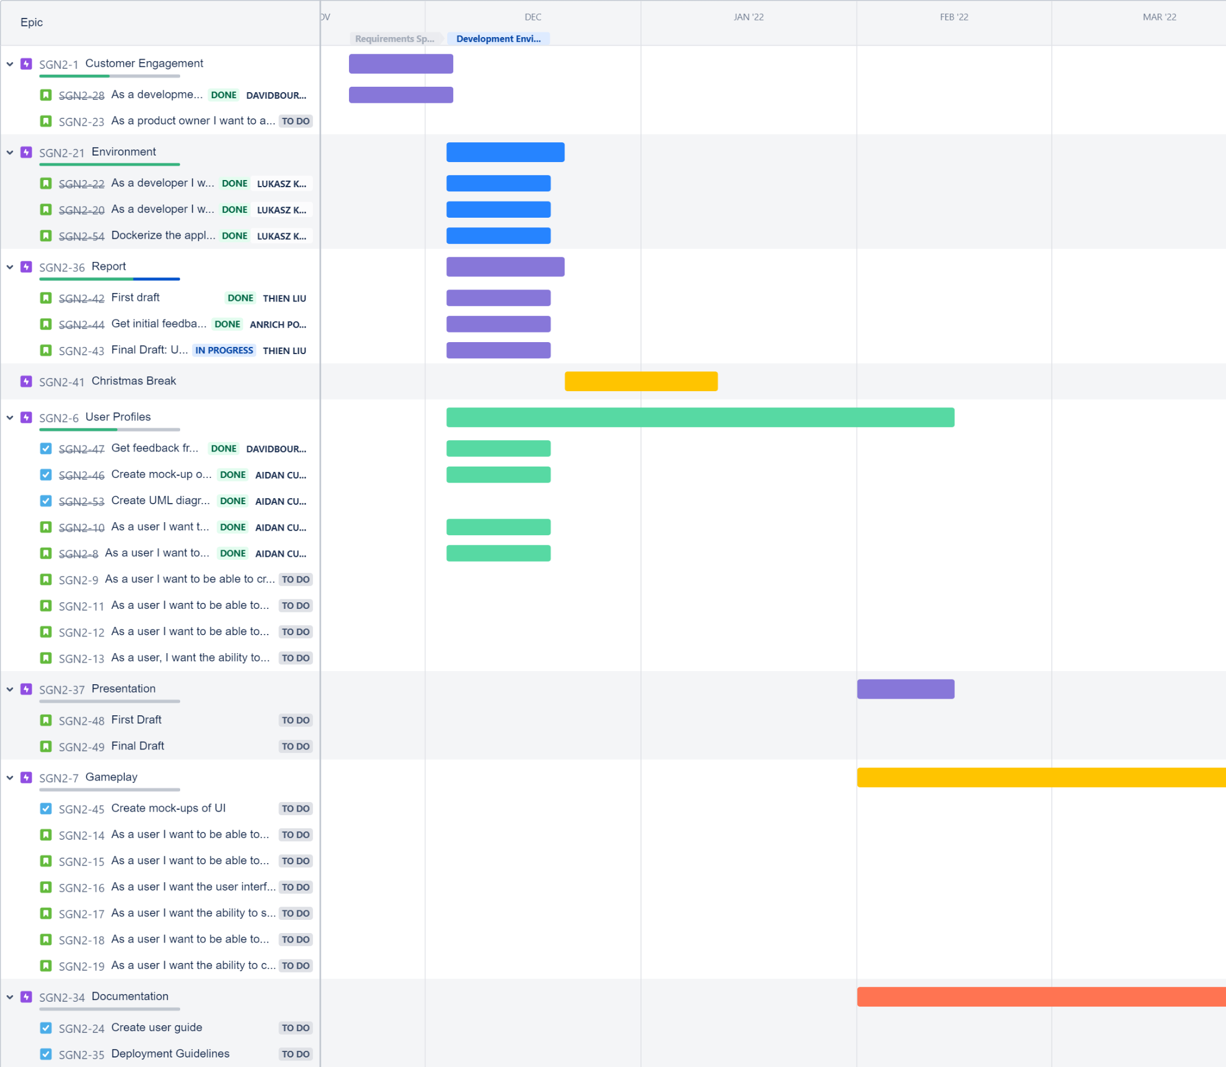

[Jira Board with Epics, Stories and Tasks](https://gp2-sepm-nov-2021.atlassian.net/jira/software/projects/SGN2/boards/1/roadmap)

# Legal Compliance

In line with the GDPR directive, users will have the right to access, edit and delete any data that is held, furthermore. Users will always be notified of any changes to their data during process or erasure (GDPR, 2017). User details are stored in a secure database where passwords are hashed using an approved python library. See Appendix D for the initial user database design.

# Communication and Documentation

The technical writer will collaborate with ChildToy to define the following:

* Installation guides
* Development guides
* API documentation
* Architecture design documentation

|  | **Sprint Commitments** | **Documentation** | **Update Report** |
| --- | --- | --- | --- |
| **Frequency** | Every two weeks | Ongoing  After each release | Weekly |
| **Content** | * Communicate sprint goals and commitments * Communicate risks, if any, for the sprint * Highlight dependencies | * Release notes * TBD with technical writer and client | * Key accomplishments * Upcoming milestones * Project management review * Risks * Overall project status |

## 

## 

## Status Report

The following table will be used as the template for project status report.

See Appendix E for report status definitions.

| **Issue/Risk** | **Action** | **Owner** | **Target** | **Status** |
| --- | --- | --- | --- | --- |
| Issue 1 | Actionable item to resolve the issue 1 | Owner Who Takes Action | Date To Complete | Refer to Appendix E - Report Status Definitions |
| Risk 1 | Actionable item to resolve the risk 1 | Owner Who Takes Action | Date To Complete | Refer to Appendix E - Report Status Definitions |

## 

# Quality Assurance

Software produced will be thoroughly tested. The test strategy includes:

* **Unit tests**: written by developers while coding.
* **Manual tests**: performed by testers to make sure the software behaves as expected.
* **Automation tests**: written and executed by testers to automate repetitive test cases.
* **Regression tests**: performed by developers after any changes have been made, pr defects have been addressed.
* **Integration/System test**: test the entire system and its dependencies in different environments.

# Project Acceptance Criteria

When all major commitments and deliverables have been closed, the project success criteria have been met.

* All issues and action items have been resolved and approved.
* Validation that the product meets the specifications
* All the executable source code and documentation have been delivered to the customer.
* A project completion statement exists.

(word count: 1044 words)

# References

Agilest®. 2021. *Why Does Scrum Work? 6 Reasons Why & Key Benefits of Scrum | Agilest®*. [online] Available at: <https://www.agilest.org/scrum/why-does-scrum-work/> [Accessed 17 December 2021].

Atlassian. 2021. *Scrum metrics | Atlassian*. [online] Available at: <https://www.atlassian.com/agile/scrum/scrum-metrics> [Accessed 17 December 2021].

‘Chapter 3 – Rights of the data subject’ (no date) General Data Protection Regulation (GDPR). Available at: https://gdpr-info.eu/chapter-3/ (Accessed: 19 December 2021).

Mishra, A. and Mishra, D. (2013) ‘Software project management tools’, ACM SIGSOFT Software Engineering Notes, 38(3), pp. 1–4. doi: 10.1145/2464526.2464537.

Mittal, P. and Mehta, P. (2020) ‘Optimization of Software Development Process by Plugin Integration with Jira – A Project Management Tool in Devops’, *SSRN Electronic Journal*, pp. 1–7. doi: 10.2139/ssrn.3564436.

QualityLogic. 2021. *10 Reasons to Use Agile Software Development - QualityLogic*. [online] Available at: <https://www.qualitylogic.com/2019/07/18/10-reasons-to-use-agile-software-development/> [Accessed 12 December 2021].

Schwaber, K. (1997). SCRUM Development Process. Business Object Design and Implementation, pp.117–134.

Sharma, S. and Hasteer, N. (2017) ‘A comprehensive study on state of Scrum development’, *Proceeding - IEEE International Conference on Computing, Communication and Automation, ICCCA 2016*, pp. 867–872. doi: 10.1109/CCAA.2016.7813837.

Srivastava, A., Bhardwaj, S. and Saraswat, S. (2017) ‘SCRUM model for agile methodology’, *Proceeding - IEEE International Conference on Computing, Communication and Automation, ICCCA 2017*, 2017-January, pp. 864–869. doi: 10.1109/CCAA.2017.8229928.

# Appendices

## Appendix A - Demo Requirements Justification

#### The system should run on L/W/IOS

One of the major requirements is to develop a system that will be reliable, flexible, and able to work on different operating systems. We have therefore decided to develop a web-based game, as the game is then able to run on all platforms.

#### Data Must be Stored in the most efficient way

Data management is crucial to the success of any project. As our game is intended to be a web based application, a relational database such as MySQL will be used.

Log-in details are to be encrypted, and will be stored independently to the player progression and history.

#### Additional languages should be available as free downloadable packs.

As we are planning a worldwide release, multiple languages will need to be available. For the purposes of the Demo, we will be enabling English and French. More languages will be available at the final release stage

#### A player should be able to create a user profile

Users should be able to create and maintain their own profiles. This would allow progression and personal preferences to be stored and reloaded. Due to the young targeted age group, parents will be able to monitor and regulate their children's profile.

#### A player should be able to create a persona

No one would like to play a boring game; therefore, it will be reasonable to represent humans using different creatures. For our case, bear, giraffe, and penguin will be our personal representation in the application. Different avatars bring more energy and interest into the game.

## Appendix B - Initial UX Design Concepts

### B.1 Login Page

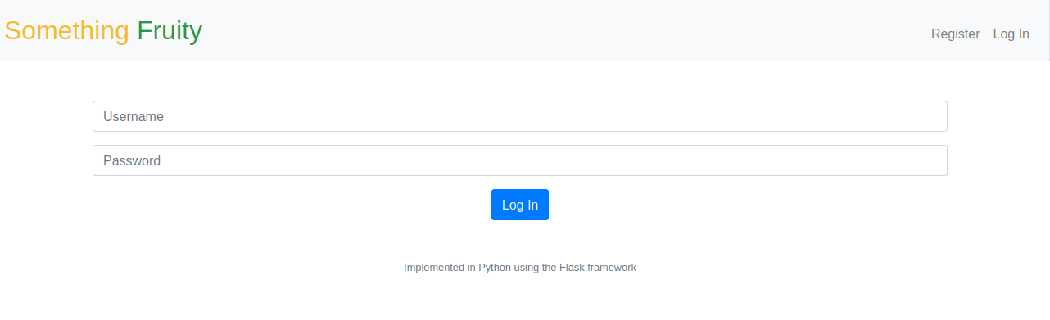

### B.2 Registration Page

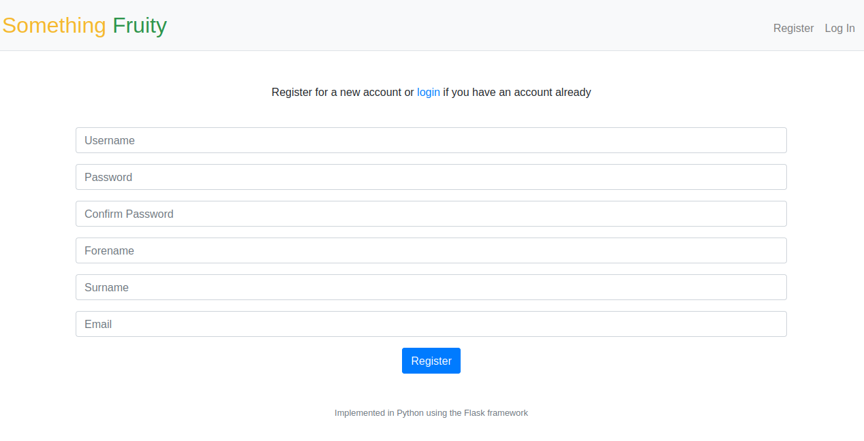

## Appendix C - Sprint Estimation

| **Task** | **Duration** | **Start** | **Finish** | **Resource** |
| --- | --- | --- | --- | --- |
| **Sprint 1 - Kickoff** | **10 days** | **06/12/21** | **17/12/21** |  |
| Infrastructure setup | 3 days | 06/12/21 | 08/12/21 | Project Team |
| Create and design the application’s structure | 10 days | 06/12/21 | 17/12/21 | Project Team |
| Initiate user guide | 2 days | 06/12/21 | 07/12/21 | Technical Writer |
| Initiate deployment guide | 2 days | 07/12/21 | 09/12/21 | Technical Writer |
| UX workshop - define UI components + wireframes | 2 days | 06/12/21 | 08/12/21 | UX Designer  Project Team |
| **Christmas Break** | **15 days** | **21/12/21** | **07/01/22** |  |
| **Sprint 2 - Speedup** | **14 days** | **10/01/22** | **24/01/22** |  |
| Account registration | 2 days | 10/01/22 | 12/01/22 | Project Team |
| Login | 2 days | 12/01/22 | 14/01/22 | Project Team |
| Start a new game | 2 days | 15/01/22 | 16/01/22 | Project Team |
| Profile details | 3 days | 16/01/22 | 19/01/22 | Project Team |
| Create user persona | 4 days | 20/01/22 | 24/01/22 | Project Team |
| UX refinement + support | 5 days | 10/01/22 | 15/01/22 | UX Designer |
| Deployment guide - draft | 2 days | 10/01/22 | 11/01/22 | Technical Writer |
| User Guide - draft | 5 days | 12/01/22 | 17/01/22 | Technical Writer |
| **Sprint 3 - Goal** | **14 days** | **26/01/22** | **09/02/22** |  |
| Gameplay implementation | 7 days | 26/01/22 | 02/02/22 | Project Team |
| Mute/Unmute | 1 day | 31/01/22 | 01/02/22 | Project Team |
| Quit game | 1 day | 02/02/22 | 03/02/22 | Project Team |
| Localisation | 4 days | 04/02/22 | 08/02/22 | Project Team |
| Delete account | 1 day | 08/02/22 | 09/02/22 | Project Team |
| User Guide - completion | 4 days | 05/02/22 | 09/02/22 | Technical Writer |
| Deployment guide - completion | 3 days | 02/02/22 | 04/02/22 | Technical Writer |
| UX refinement + support | 5 days | 31/01/22 | 04/02/22 | UX Designer |

## Appendix D - Initial ERD Design

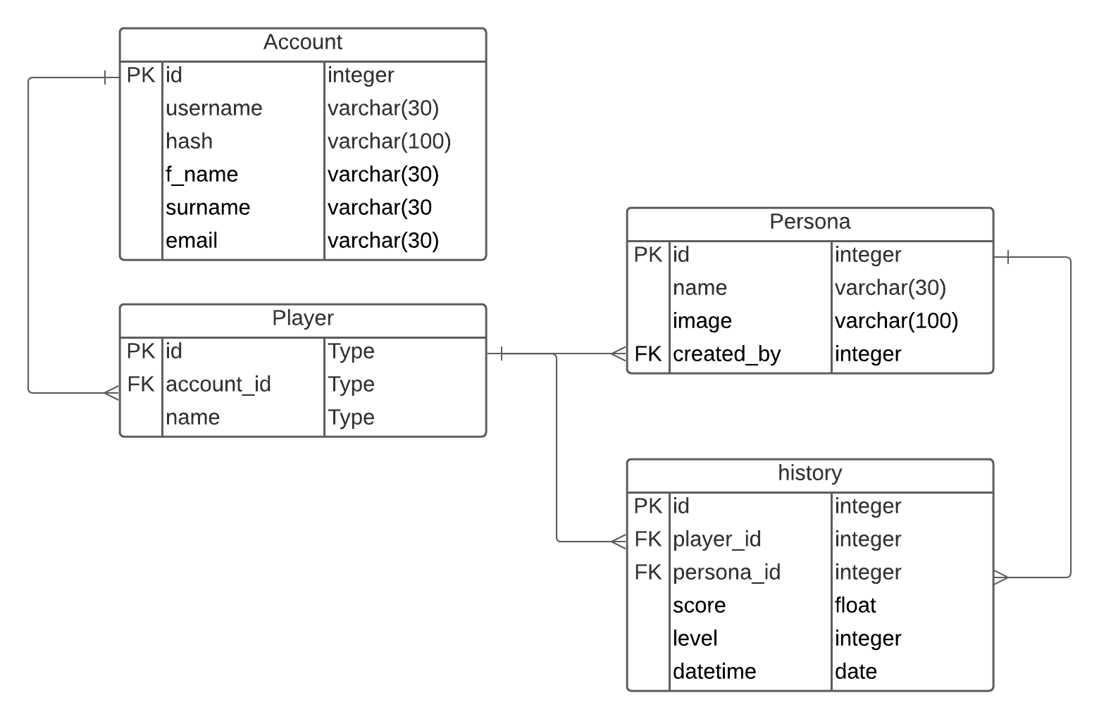

## Appendix E - Report Status Definitions

| **COMPLETE** | Milestone is complete as of the date noted |
| --- | --- |
| **TBD** | Dates are pending following planning sessions |
| **GREEN** | On schedule, on budget, no significant risks or issues |
| **AMBER** | There are problems with the schedule or the budget, but they can be fixed with corrective actions. |
| **RED** | There are serious issues, and the project is either delayed or has a significant budget overrun. |

## 

## Appendix F - Scope Change Management

Project plan information is subject to change as the project progresses. Although the changes are safe and necessary, it is important to note that changes to the project plan affect at least one of three key success factors: time available, resources available, or quality of the project. Decisions about changing the project plan should be adjusted by following these steps:

* **Step 1** - As soon as changes that affect project scope, schedule, staffing, or expenses are identified, the project manager documents the issue.
* **Step 2** - The project team reviews the changes, determines the impact associated with the project, and ultimately decides whether to approve or reject the changes.
* **Step 3** - After approval or rejection (by the project team or administrator), the project manager will notify the original applicant of the steps taken. There is no appeal procedure.